**Task 1**

Kernel Architecture Diagram - Draw a detailed diagram of the Linux kernel architecture. Label and write a short description (2-3 sentences) for each major component like Scheduler, File System, Network Stack, etc.   
  
  
**Flow Diagram –**

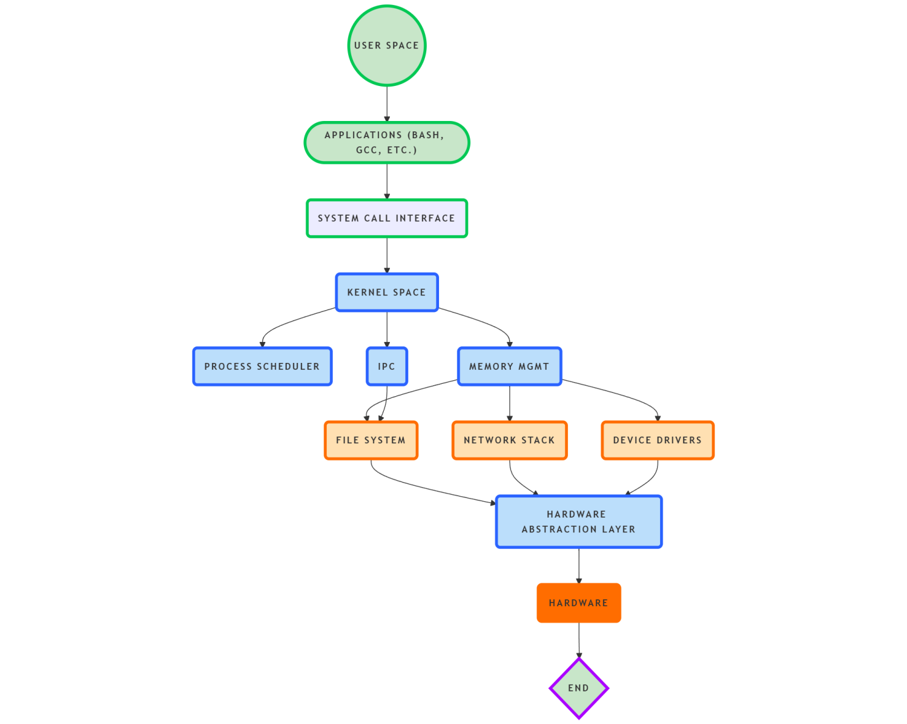

**Conceptual diagram of the Linux kernel architecture**

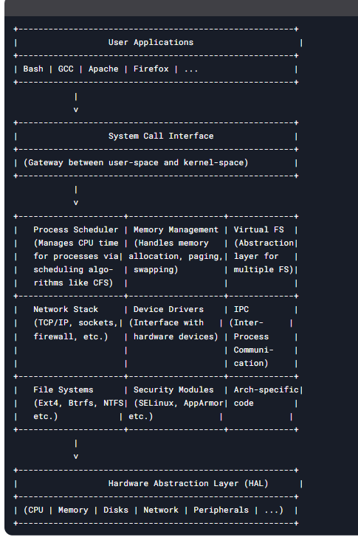

**Key Components Explained:**

1. **System Call Interface**  
   The gateway between user applications and kernel services, providing controlled access to hardware/resources via ~400 syscalls.
2. **Process Scheduler**  
   Manages CPU time allocation using algorithms like CFS (Completely Fair Scheduler), ensuring multitasking and process prioritization.
3. **Memory Management**  
   Handles virtual memory, paging, swapping, and memory allocation via buddy system and slab allocator.
4. **Virtual File System (VFS)**  
   Abstraction layer that unifies access to different filesystems (Ext4, NTFS, etc.) through common interfaces.
5. **Network Stack**  
   Implements TCP/IP protocols, sockets, firewalls (netfilter), and network device drivers for communication.
6. **Device Drivers**  
   Kernel modules that interface with hardware devices (storage, USB, GPU, etc.) through standardized APIs.
7. **IPC (Inter-Process Communication)**  
   Mechanisms like pipes, shared memory, and message queues for process coordination.
8. **Security Modules**  
   Framework for mandatory access control (e.g., SELinux) and capability-based security.
9. **Arch-Specific Code**  
   Low-level hardware-dependent code for different CPU architectures (x86, ARM, etc.).